CATAPULT T-SHIRTS FOR SALE!

Want to show your excitement for this year’s **Spiritual Emphasis Week known as (Catapult)** coming soon? Here is one way you can. Wear a themed t-shirt! The image shows what the t-shirts will look like with some added details and sizing helps below. Order forms are due **NO LATER THAN MONDAY, SEPTEMBER 21st** to the office. We will be shipwrecked with the Apostle Paul in need of being “Rescued by Jesus” on **October 13 – 16.** These theme t-shirts can be worn to build excitement throughout that special week. These can also be worn on future Fridays as CCA apparel. Though this event is only for the CCA elementary grades, adult shirts are available for parents and staff to help join in the spirit!

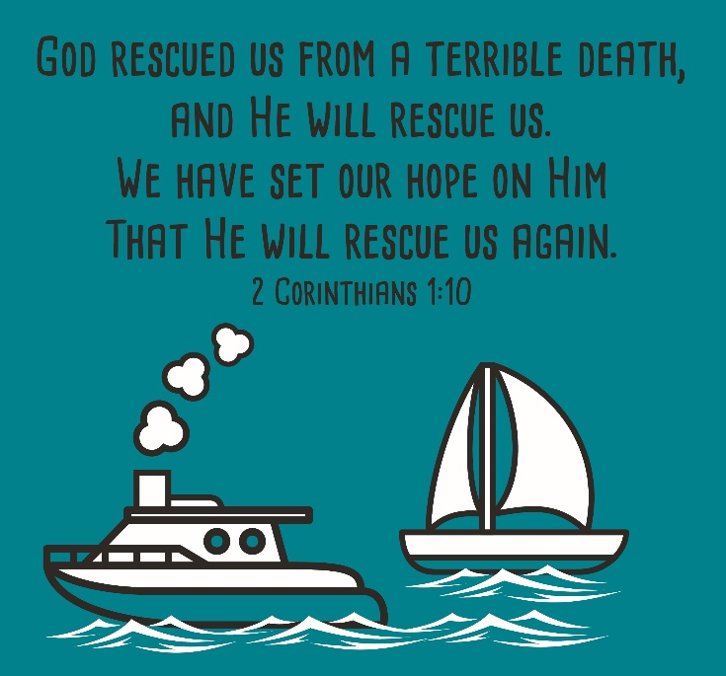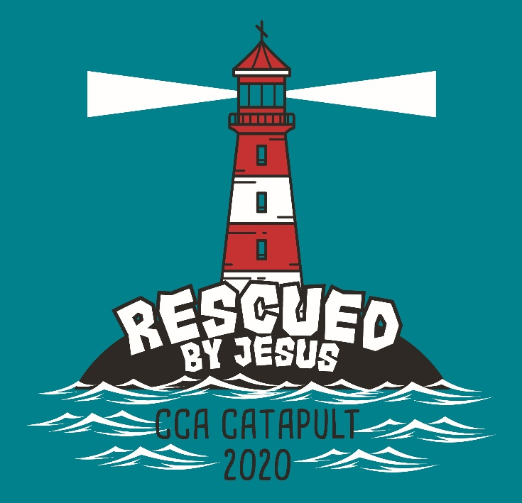

**ADULT MEASUREMENTS**

**S M L XL 2XL 3XL 4XL 5XL**

Body Length 28 29 30 31 32 33 34 35

Body Width 18 20 22 24 26 28 30 32

100% preshrunk cotton

**YOUTH (KIDS) MEASUREMENTS**

**XS S M L XL**

Body Length 20 1/2 22 23 1/2 25 26 1/2

Body Width 16 17 18 19 20

Sizes 6-8 10-12 14-16 18-20 22-24

100% preshrunk cotton

**How to Measure**: **BODY LENGTH:** Lay garment flat (face down). Measure from center back neckline seam straight down to bottom of the front hem. **BODY WIDTH:** Lay garment flat. 1" below the armhole flat measure the garment across the chest.

**Have questions? Email Melanie Wetzel (**[**mwetzel@carlislechristian.org**](mailto:mwetzel@carlislechristian.org)**)**

**SUBMIT FORM BY MONDAY. SEPTEMBER 21st**

**NO LATE ORDERS CAN BE ACCEPTED!**

____________________________ (student’s name) would like the following shirts ordered. **The cost is $12 with the exception of 2XL and larger being $14.**

**Please indicate with a Y if the size is youth(kids). If you do not use a Y this is assuming you want an adult size. Examples: YS (Youth(kids) Small) M (Adult Medium)**

SIZE ____ QUANTITY ____ SIZE _____ QUANTITY ____

SIZE ____ QUANTITY ____ SIZE ____ QUANTITY_____

Included is my cash or check (made to CCA) payment of $__________

I authorize payment in the amount of $_________ to be charged to my FACTS account for my child’s Catapult t-shirt purchase.

Signature _______________________________________ Date _____________